|  |  |
| --- | --- |
| Ex.No:5 | **SERVER SIDE PROCESSING** |
| Date: |

AIM:

To design a website to perform mathematical calculations in server side. ALGORITHM:

Step 1: Design your website for calculation using wireframe work.

Step 2: Then to execute the wireframe work desing use html,css

Step 3: Use views.py to execute the coding in serverside

Step 4: Mention the path of the website in urls.py

Step 5: Publish the website in the given URL.

PROGRAM:

HTML:

Math.py

<html>

<head>

<meta charset='utf-8'>

<meta http-equiv='X-UA-Compatible' content='IE=edge'>

<title>Area of Prism</title>

<meta name='viewport' content='width=device-width, initial-scale=1'>

<style type="text/css">

body

{

background-color:cyan;

}

.edge {

width: 1080px;

margin-left: auto;

margin-right: auto;

padding-top: 200px;

padding-left: 300px;

}

.box {

display:block;

border: Thick dashed lime;

width: 500px;

min-height: 300px;

font-size: 20px;

background-color: purple;

}

.formelt{

color: Red;

text-align: center;

margin-top: 5px;

margin-bottom: 5px;

}

h1

{

color: yellow;

Text-align: center;

padding-top: 20px;

}

</style>

</head>

<body>

<div class="edge">

<div class="box">

<h1>Area of a Prism</h1>

<form method="POST">

{% csrf_token %}

<div class="formelt">

Side : <input type="text" name="side" value="{{s}}"></input>(in m)<br/>

</div>

<div class="formelt">

Height : <input type="text" name="height" value="{{h}}"></input>(in m)<br/>

</div>

<div class="formelt">

<input type="submit" value="Calculate"></input><br/>

</div>

<div class="formelt">

Area : <input type="text" name="area" value="{{area}}"></input>m<sup>2</sup><br/>

</div>

</form>

</div>

</div>

</body>

</html>

Urls.py

from django.contrib import admin

from django.urls import path

From myapp import views

urlpatterns = [

    path('admin/', admin.site.urls),

    path('areaofprism/',views.prismarea,name="areaofprism"),

]

Views.py

from django.shortcuts import render

from django.template  import loader

from django.shortcuts import render

# Create your views here.

def prismarea(request):

    context={}

    context['area'] = "0"

    context['s'] = "0"

    context['h'] = "0"

    if request.method == 'POST':

        print("POST method is used")

        s = request.POST.get('side','0')

        h = request.POST.get('height','0')

        print('request=',request)

        print('Side=',s)

        print('Height=',h)

        area = 2*int(s)*int(s) + 4*int(h)*int(s)

        context['area'] = area

        context['s'] = s

        context['h'] = h

        print('Area=',area)

    return render(request,'myapp/math.html',context)

OUTPUT:

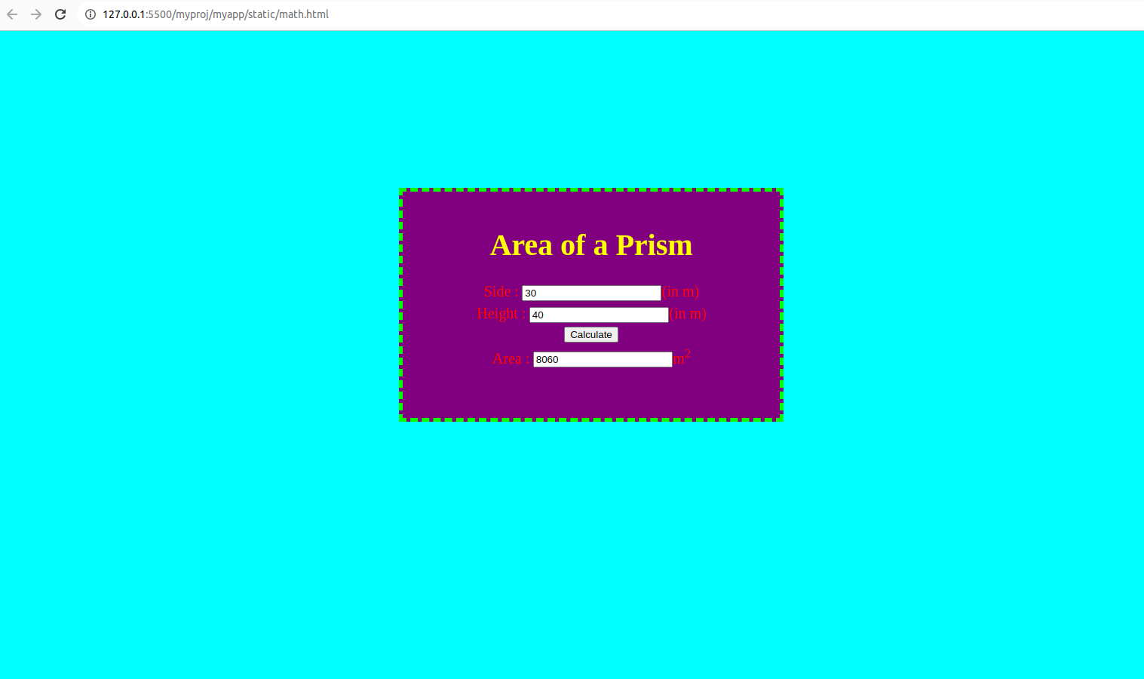

RESULT:

The program is executed successfully.